LECTURE 14



Drude model:  
1. Physical components:Consider a conductor as a regular array of atoms plus a collection of free electrons, which are sometimes called conduction electrons. We identify the system  
as the combination of the atoms and the conduction electrons.

2. Behavior of the components:(a) In the absence of an electric field, the conduction electrons move in random directions through the conductor (Fig. 27.3a).

conduction electrons in a metal behave as an *electron gas*

**b)** When an electric field is applied to the system, the free electrons drift slowly in a direction opposite that of the electric field (Fig. 27.3b),

**(c)** The electron’s motion after a collision is independent of its motion before the collision. The work done on them by the electric field is transferred to the atoms of the conductor when the electrons and atoms collide.

the energy transferred to the atoms causes the internal energy of the system and, therefore, the temperature of the conductor to increase.

Model: a free electron of mass me and charge -e in an electric field **E**

Force exerted on the electron: $\vec{F}= q∙\vec{E}$ where q is a carrier charge (for electron: -e = - 1.6 10-19 C)

Newton’s second law:



a carrier moves with constant acceleration **a**

Hence, before two successive collisions,



where t – is a time interval between two successive collisions

Let’s take an average value of **vf** for all possible initial velocities and time intervals t



the average initial velocity is zero, and the average time interval between successive collisions is τ Let’s substitute average velocity into 27.4:





dividing by A, we get the expression for the current density:



From Ohm’s law:

$$J= σ∙E$$

Hence, conductivity:



and resistivity:



We see that resistivity and conductivity do not depend on the E field.

average time interval between collisions τ:

$τ= {l_{avg}}/{v_{avg}}$ (27.17)

where lavg is the ‘mean free pass’

vavg – average speed

Although this structural model of conduction is consistent with Ohm’s law, it does not correctly predict the values of resistivity or the behavior of the resistivity with temperature

For example, the results of classical calculations for *v*avg using the  
ideal gas model for the electrons are about a factor of ten smaller than the actual values, which results in incorrect predictions of values of resistivity from Equation 27.16.

Furthermore, according to Equations 27.16 and 27.17, the resistivity is predicted to vary with temperature as does *v*avg, which, according to an ideal-gas model (Chapter 21, Eq. 21.43), is proportional to "*T*. This behavior is in disagreement with the experimentally observed linear dependence of resistivity with temperature  
for pure metals.





α is a temperature coefficient of resistivity





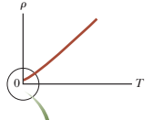 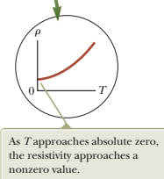

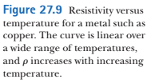

For some metals such as copper, resistivity is nearly proportional to temperature as shown in Figure 27.9. A nonlinear region always exists at very low temperatures, however, and the resistivity usually reaches some finite value as the temperature approaches absolute zero

This residual resistivity near absolute zero is caused primarily by the collision of electrons with impurities and imperfections in the metal. In contrast, high-temperature resistivity (the linear region) is predominantly characterized by collisions between electrons and metal atoms.

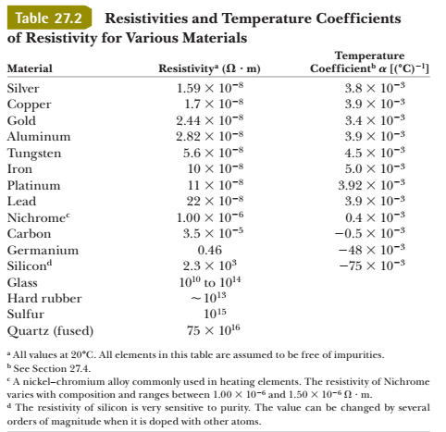

Notice that three of the α values in Table 27.2 are negative, indicating that the resistivity of these materials decreases with increasing temperature. This behavior is indicative of a class of materials called *semiconductors*

